Name:_____________________________________ Period: ___________ Date: __________

Overview of Photosynthesis - Label the Diagram

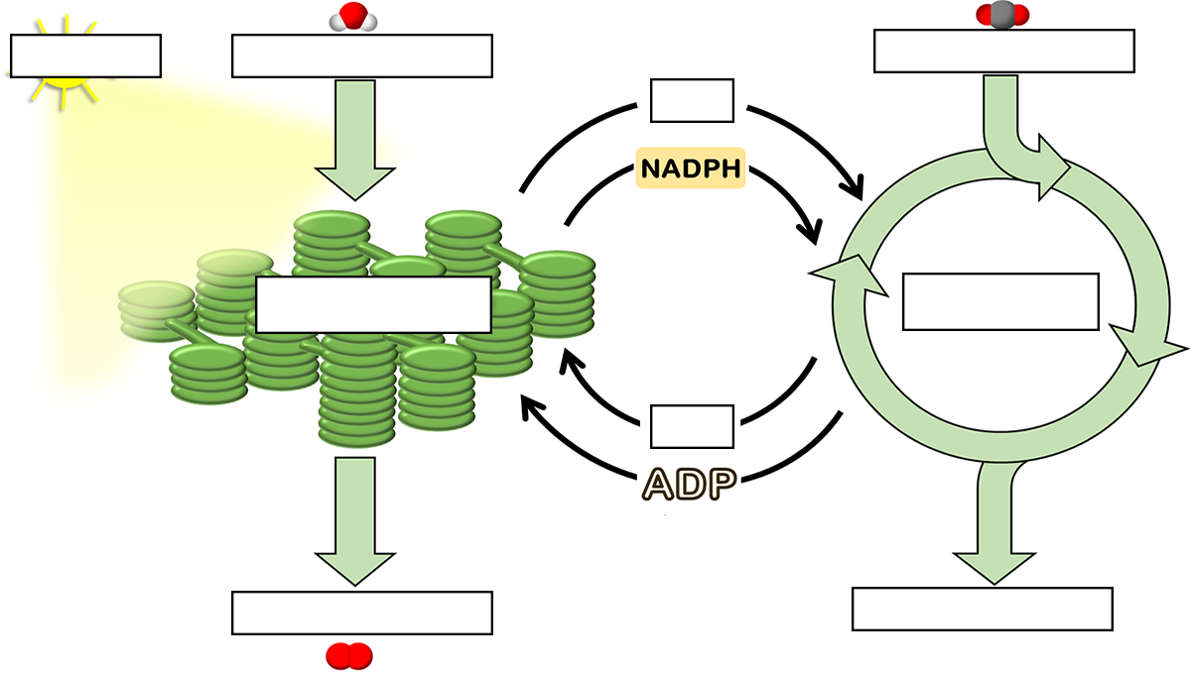

Photosystem 1 and Photosystem 2 - Identify each structure / process

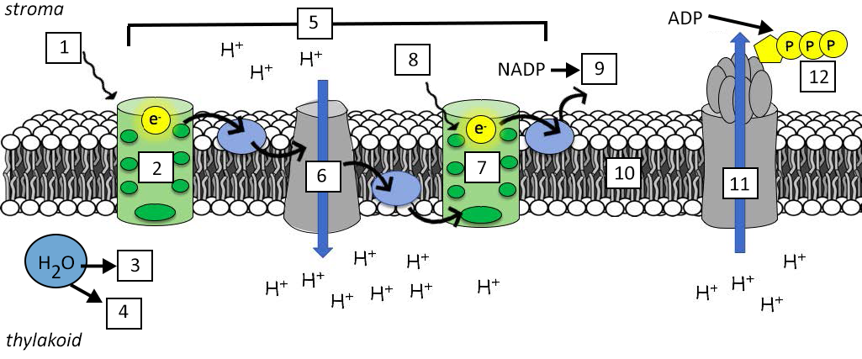

___ Electron Transport Chain ____ Light (700 nm) ___ Light (680 nm) ____ NADPH
___ Photosystem I ____ Photosystem II ___ Oxygen ____ H+
___ Thylakoid membrane ____ ATP Synthase ___ Cytochrome ____ ATP

